Module-5 Critical Thinking Assignment
Option-2: Building a Random Forest Classifier (Iris Dataset)

Jibran Gill
Colorado State University Global
CSC580 – Applying Machine Learning and Neural Networks - Capstone
Dr. Bingdong Lee

Table of Contents
Introduction 3
Methodology 3
Data Generation and Preprocessing 3
Feature Selection and Target Encoding 4
Model Construction and Training 4
Model Evaluation and Results 5
Training and Test Accuracy 5
Predicted vs. Actual Species 6
Confusion Matrix Analysis 7
Prediction Confidence 8
Feature Importance 9
Results Summary 10
Conclusion 11
References 11
Appendix-A: Program Source Code 12
Appendix-B: Program Outputs 17

Option-2: Building a Random Forest Classifier (Iris Dataset)

Introduction
This assignment presents the implementation and evaluation of a Random Forest classifier for multiclass classification using the well-known Iris dataset. The objective of the model is to correctly classify iris flower samples into one of three species, Setosa, Versicolor, or Virginic. Classification is based on four numerical measurements which are sepal length, sepal width, petal length, and petal width.
Random Forest is an ensemble learning method that combines the predictions of multiple decision trees to improve generalization and robustness. Unlike linear models, Random Forests can capture nonlinear decision boundaries and feature interactions without requiring explicit feature engineering. This makes the algorithm particularly well-suited for structured tabular datasets such as the Iris dataset.
The purpose of this exercise is to reinforce understanding of ensemble classifiers, train/test evaluation, feature importance analysis, and model behavior under varying levels of complexity. Visualizations and quantitative metrics are used together to interpret the model’s performance and limitations.

Methodology

Data Generation and Preprocessing
The dataset used in this assignment was provided as a CSV file containing numerical measurements and a pre-encoded target variable. The dataset consists of 120 samples, each with four feature variables and one target label. The target variable is encoded as integers, where:
- 0 represents Setosa
- 1 represents Versicolor
- 2 represents Virginica
The dataset was loaded using Pandas, and column names were standardized for clarity. A fixed random seed was applied to ensure reproducibility of results across executions.
To evaluate generalization performance, the dataset was split into training and test subsets using a 75/25 random split. This resulted in 94 samples used for training and 26 samples held out for testing.
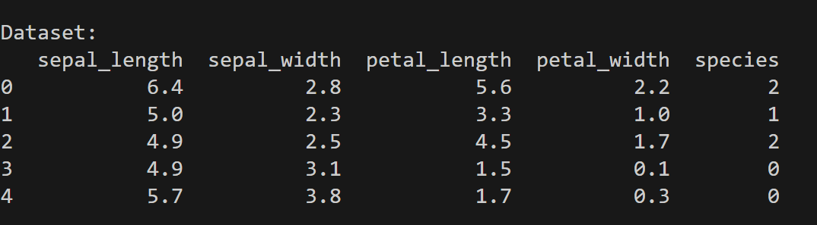
Figure 1: Head of Iris Dataset After Loading and Preprocessing

Feature Selection and Target Encoding
All four numeric measurements, i.e. sepal length, sepal width, petal length, and petal width were used as input features. No feature scaling was required because Random Forest classifiers are invariant to monotonic transformations of input features.
The target variable required no additional encoding, as the species labels were already represented as integer class values. This simplified preprocessing compared to approaches that require label encoding or one-hot encoding.

Model Construction and Training
A Random Forest classifier was constructed using Scikit-learn’s RandomForestClassifier. The baseline model was trained with 100 decision trees and default hyperparameters. Parallel training was enabled to improve efficiency, and a fixed random state ensured reproducibility.
The model was trained using the training subset only. After training, both training accuracy and test accuracy were computed to assess whether the model exhibited underfitting or overfitting behavior.
The baseline Random Forest achieved perfect accuracy on the training data and strong performance on the unseen test data, indicating a high-capacity model with good generalization.

Model Evaluation and Results

Training and Test Accuracy
The baseline Random Forest classifier achieved a training accuracy of 1.0000 and a test accuracy of 0.9231. While perfect training accuracy suggests that the model can fully fit the training data, the slightly lower test accuracy indicates a small amount of generalization error, which is expected for real-world datasets.
To better understand model complexity, two additional models were trained for comparison: an underfit model with shallow trees (max_depth = 2) and a more complex model with 300 trees. The underfit model showed reduced training accuracy but nearly identical test accuracy, while the more complex model did not improve test performance beyond the baseline.
This comparison demonstrates diminishing returns from increasing model complexity once sufficient capacity has been reached.
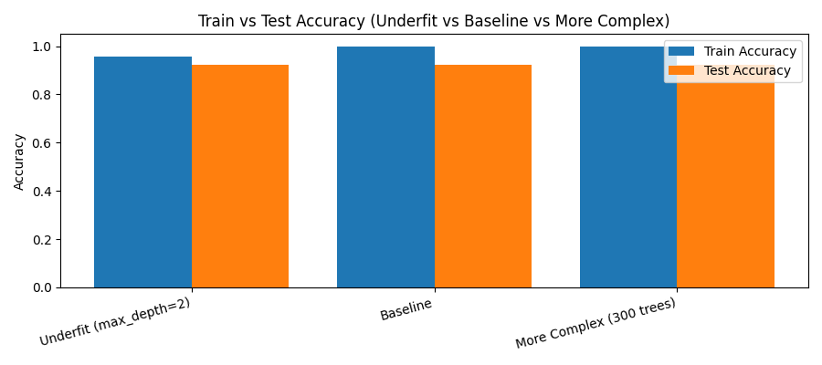
Figure 2: Train vs Test Accuracy for Underfit, Baseline, and More Complex Models

Predicted vs. Actual Species
A scatter plot was generated comparing actual and predicted species labels for the test dataset. The visualization shows that most predicted points align directly with their corresponding true labels. Misclassifications occur only between Versicolor and Virginica, while Setosa samples are classified perfectly.
This behavior aligns with known properties of the Iris dataset, where Setosa is linearly separable, while Versicolor and Virginica exhibit partial feature overlap.
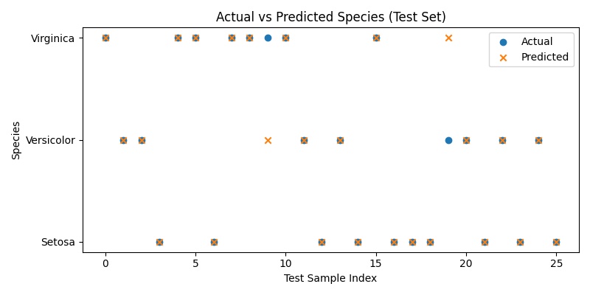
Figure 3: Actual vs Predicted Species for Test Set

Confusion Matrix Analysis
A confusion matrix was computed to quantify classification performance across all three species. The matrix shows that all Setosa samples were classified correctly. For Versicolor and Virginica, one misclassification occurred in each direction, resulting in a recall of 0.875 for both classes.
The normalized confusion matrix further highlights that misclassification is symmetric between Versicolor and Virginica, reinforcing the conclusion that these two species are more difficult to distinguish based solely on feature measurements.
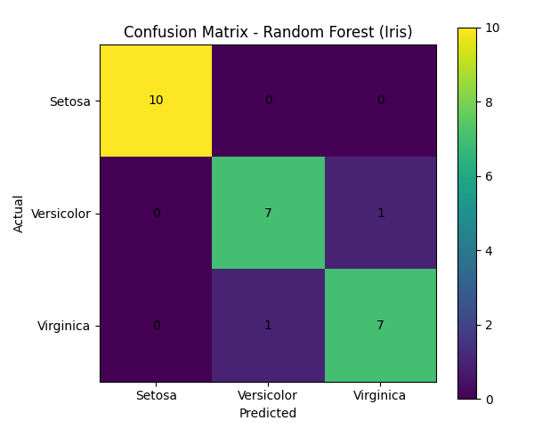
Figure 4: Confusion Matrix for Random Forest Classifier

Prediction Confidence
Predicted class probabilities were examined to assess model confidence. Most predictions had a maximum probability greater than 0.9, indicating strong confidence in the majority of classifications. A small number of lower-confidence predictions corresponded to the misclassified samples, demonstrating that reduced confidence can serve as a useful indicator of uncertain decisions.

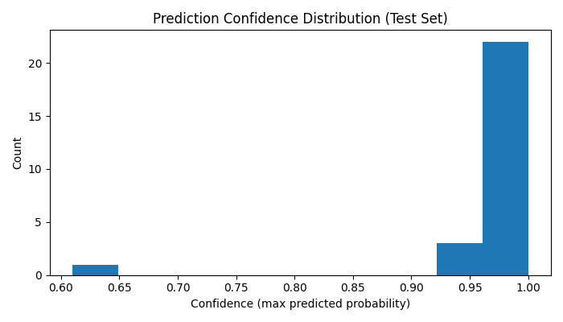
Figure 5: Prediction Confidence Distribution for Test Set

Feature Importance
Random Forest models provide an intrinsic measure of feature importance based on how frequently and effectively each feature is used for splitting across trees. Analysis of feature importance revealed that petal width and petal length were the most influential features, together accounting for the majority of predictive power.
Sepal length and sepal width contributed significantly less, with sepal width being the least important feature overall. These results are consistent with botanical intuition and prior analyses of the Iris dataset.
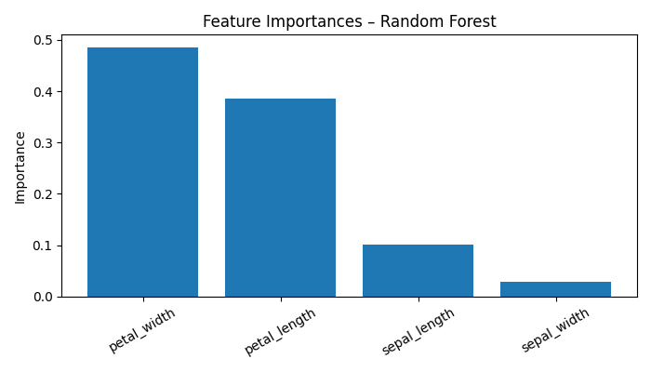
Figure 6: Feature Importance Scores from Random Forest

Results Summary
The results demonstrate that Random Forest classifiers are highly effective for structured, low-dimensional datasets. The model achieved strong accuracy without extensive preprocessing or hyperparameter tuning. While the baseline model fully fit the training data, its test performance remained stable, indicating controlled overfitting rather than severe memorization.
The comparison between underfit, baseline, and more complex models illustrates an important principle in machine learning: increasing model complexity does not guarantee improved generalization. In this case, additional trees improved training fit but offered no measurable benefit on unseen data.
Misclassifications were limited to ambiguous samples where feature overlap exists between Versicolor and Virginica, highlighting the inherent limits of the dataset rather than deficiencies in the model.

Conclusion
This assignment demonstrated the application of a Random Forest classifier for multiclass classification using the Iris dataset. Key concepts reinforced include ensemble learning, model evaluation using train/test splits, confusion matrix interpretation, feature importance analysis, and the trade-off between model complexity and generalization.
The Random Forest classifier achieved high accuracy with minimal preprocessing and provided interpretable insights through feature importance scores. These results underscore why Random Forests remain a strong baseline model for many real-world classification problems involving structured data.

References
- GeeksforGeeks. (2024). Random Forest Algorithm in Machine Learning.
https://www.geeksforgeeks.org/random-forest-algorithm-in-machine-learning/
- Scikit-learn Developers. (2024). RandomForestClassifier Documentation.
https://scikit-learn.org/stable/modules/generated/sklearn.ensemble.RandomForestClassifier.html
- Brownlee, J. (2023). How to Use Random Forest for Classification. Machine Learning Mastery.
https://machinelearningmastery.com/random-forest-classifier-python/
- Stack Overflow Community. (2024). Interpreting Feature Importance in Random Forest Models.
https://stackoverflow.com/questions/15810339
- Matplotlib Developers. (2024). Matplotlib Visualization Library.
https://matplotlib.org/stable/

Appendix-A: Program Source Code
"""
CSC580 - Module 5 Option #2 Random Forest Classifier
Jibran Gill
"""

import pandas as pd
import numpy as np
import matplotlib.pyplot as plt
from sklearn.ensemble import RandomForestClassifier
from sklearn.metrics import accuracy_score, confusion_matrix, classification_report
import warnings
warnings.filterwarnings("ignore", category=RuntimeWarning)

#Load the data
np.random.seed(0)
df = pd.read_csv("iris_training.csv")

#Data processing - rename columns
df.columns = [
"sepal_length",
"sepal_width",
"petal_length",
"petal_width",
"species"
]

print("\nDataset:")
print(df.head())

#Create training and test data using the 75/25 split
df["is_train"] = np.random.uniform(0, 1, len(df)) <= 0.75
print("\nSDataset with is_train column: ")
print(df.head())
train = df[df["is_train"]].copy()
test = df[~df["is_train"]].copy()
print("\n Train/Test counts: ")
print("Training samples:", len(train))
print("Test samples:", len(test))

#Preprocess the data
features = ["sepal_length", "sepal_width", "petal_length", "petal_width"]
X_train = train[features]
y_train = train["species"]
X_test = test[features]
y_test = test["species"]
print("\nFeature list: ")
print(features)
print("\n Encoded target values: ")
print(y_train.head(25).to_numpy())

#Training the Random Forest Classifier
clf = RandomForestClassifier(
n_estimators=100,
random_state=0,
n_jobs=2
)
clf.fit(X_train, y_train)
print("\nRandom Forest trained: ")

#Train/Test accuracy for main model
train_acc = accuracy_score(y_train, clf.predict(X_train))
test_preds_for_acc = clf.predict(X_test)
test_acc = accuracy_score(y_test, test_preds_for_acc)
print("\nMain Model Accuracy: ")
print(f"Training Accuracy: {train_acc:.4f}")
print(f"Test Accuracy: {test_acc:.4f}")

# Predicted probabilities (first 10 test samples)
probs = clf.predict_proba(X_test)
probs_df = pd.DataFrame(
probs[:10],
columns=["P(Setosa)", "P(Versicolor)", "P(Virginica)"]
)
print("\nPredicted probabilities (first 10): ")
print(probs_df)

#Add predicted class + confidence for first 10
preds_all = clf.predict(X_test)
conf_all = probs.max(axis=1)
first10_summary = pd.DataFrame({
"Actual Species": y_test.iloc[:10].to_numpy(),
"Predicted Species": preds_all[:10],
"Confidence (max prob)": conf_all[:10]
})
print("\nFirst 10: Actual vs Predicted + Confidence (optional screenshot):")
print(first10_summary)

#Confidence histogram
plt.figure(figsize=(7, 4))
plt.hist(conf_all, bins=10)
plt.title("Prediction Confidence Distribution (Test Set)")
plt.xlabel("Confidence (max predicted probability)")
plt.ylabel("Count")
plt.tight_layout()
plt.show()

#Predicted vs Actual (first 5 observations)
preds = clf.predict(X_test)
compare5 = pd.DataFrame({
"Actual Species": y_test.iloc[:5].to_numpy(),
"Predicted Species": preds[:5]
})
print("\nActual vs Predicted (first 5)")
print(compare5)

#Classification report
print("\nClassification Report (optional, good for write-up):")
print(classification_report(y_test, preds, digits=4))

#Show misclassified rows (if any)
mis_mask = (y_test.to_numpy() != preds)
mis_idx = test.index[mis_mask]

print("\nMisclassifications summary (optional, great for discussion):")
print(f"Total misclassified: {mis_mask.sum()} out of {len(test)}")

if mis_mask.sum() > 0:
mis_df = test.loc[mis_idx, features + ["species"]].copy()
mis_df["predicted"] = preds[mis_mask]
print("\nMisclassified samples (showing up to first 10):")
print(mis_df.head(10))
else:
print("No misclassifications in this test split.")

# Confusion Matrix
cm = confusion_matrix(y_test, preds)
cm_df = pd.DataFrame(
cm,
index=["Setosa", "Versicolor", "Virginica"],
columns=["Setosa", "Versicolor", "Virginica"]
)
print("\nConfusion Matrix table: ")
print(cm_df)

#Confusion matrix normalized
cm_row_sums = cm.sum(axis=1, keepdims=True)
cm_norm = np.divide(cm, cm_row_sums, out=np.zeros_like(cm, dtype=float), where=cm_row_sums != 0)

cm_norm_df = pd.DataFrame(
cm_norm,
index=["Setosa", "Versicolor", "Virginica"],
columns=["Setosa", "Versicolor", "Virginica"]
)
print("\nNormalized Confusion Matrix (row-wise proportions):")
print(cm_norm_df.round(3))

# Heatmap-style plot
plt.figure(figsize=(6, 5))
plt.imshow(cm)
plt.title("Confusion Matrix - Random Forest (Iris)")
plt.colorbar()
plt.xticks([0, 1, 2], ["Setosa", "Versicolor", "Virginica"])
plt.yticks([0, 1, 2], ["Setosa", "Versicolor", "Virginica"])

for i in range(3):
for j in range(3):
plt.text(j, i, cm[i, j], ha="center", va="center")

plt.xlabel("Predicted")
plt.ylabel("Actual")
plt.tight_layout()
plt.show()

#Feature importance
importances = pd.DataFrame({
"Feature": features,
"Importance": clf.feature_importances_
}).sort_values("Importance", ascending=False)
print("\nFeature importance scores: ")
print(importances)
plt.figure(figsize=(7, 4))
plt.bar(importances["Feature"], importances["Importance"])
plt.title("Feature Importances – Random Forest")
plt.ylabel("Importance")
plt.xticks(rotation=30)
plt.tight_layout()
plt.show()

#Print top feature(s) explicitly
top_feature = importances.iloc[0]["Feature"]
top_importance = importances.iloc[0]["Importance"]
print("\nTop Feature:")
print(f"{top_feature} (importance = {top_importance:.4f})")

# Actual vs Predicted plot
plt.figure(figsize=(8, 4))
plt.scatter(range(len(y_test)), y_test, label="Actual", marker="o")
plt.scatter(range(len(preds)), preds, label="Predicted", marker="x")
plt.yticks([0, 1, 2], ["Setosa", "Versicolor", "Virginica"])
plt.xlabel("Test Sample Index")
plt.ylabel("Species")
plt.title("Actual vs Predicted Species (Test Set)")
plt.legend()
plt.tight_layout()
plt.show()

# Underfit vs Baseline
models = {
"Underfit (max_depth=2)": RandomForestClassifier(max_depth=2, n_estimators=50, random_state=0),
"Baseline": RandomForestClassifier(random_state=0),
"More Complex (300 trees)": RandomForestClassifier(n_estimators=300, random_state=0),
}

rows = []
for name, model in models.items():
model.fit(X_train, y_train)
train_acc = accuracy_score(y_train, model.predict(X_train))
test_acc = accuracy_score(y_test, model.predict(X_test))
rows.append((name, train_acc, test_acc))
scores = pd.DataFrame(rows, columns=["Model", "Train Accuracy", "Test Accuracy"])

print("\nUnderfit vs Baseline vs More Complex")
print(scores)

#Plot train vs test accuracy comparison
plt.figure(figsize=(9, 4))
x = np.arange(len(scores))
plt.bar(x - 0.2, scores["Train Accuracy"], width=0.4, label="Train Accuracy")
plt.bar(x + 0.2, scores["Test Accuracy"], width=0.4, label="Test Accuracy")
plt.xticks(x, scores["Model"], rotation=15, ha="right")
plt.ylim(0, 1.05)
plt.title("Train vs Test Accuracy (Underfit vs Baseline vs More Complex)")
plt.ylabel("Accuracy")
plt.legend()
plt.tight_layout()
plt.show()

Appendix-B: Program Outputs

